SOCIAL MEDIA CONTENT PRODUCTION
Activity Workbook

You will use this activity workbook to produce a total four social media content products:

- Sign-On Page Copy

- Metadata Copy

- Three Tweets

- Three Facebook Posts

You will begin to produce your work during the live webinar on Thursday. You will complete your social media content production after class and submit your work for review by Tuesday, September 27 at 9:00am.

RESOURCE BANK

Training Slides for Review: Social Media Content Production Slides

Article: Obama Designates 1st Marine National Monument in the Atlantic Ocean

GIF Site: http://giphy.com/

ACTIVITY #1: BRAINSTORMING [15 MINUTES]

This article came out on September 15, 2016: Obama Designates 1st Marine National Monument in the Atlantic Ocean Brainstorm a social media campaign around this article. Your campaign will have three components:
- Sign-On Page to collect supporters information and mobilize them around this issue. It is up to you what your mobilization ask will be.
- Twitter Messages that inform your audience about the issue and lead them to your Sign-On page.
- Facebook posts that inform your audience about the issue and lead them to your Sign-On page.

Brainstorm what your strategy will be by answering the questions below. Remember: You are a Digital Content Producer at Climate STRONG, an issue-advocacy organization focused on calling out Climate Deniers. Your supporters are spread across the country and work locally to fight against climate change.

- What is the goal of your campaign?

- What do you want your members to do?

- What is your message? (Hook + Call to Action + Why should someone act?)

- Who is your audience? (Remember, you are reaching out to them on TW and FB)

ACTIVITY #2: PRODUCE A SIGN-ON PAGE [15 MINUTES]

Produce a Sign-On page for your social media campaign. As part of the Sign-On page, write a title for the page, text, and space to collect email information (email, ZIP code).
Remember, your Sign-On page is where your audience will land if they respond to your mobilization ask on social media. A Sign-On page usually uses a “Call to Action” as title, is short, and collects someone’s email and zip code. In some occasions, depending on the goal of the campaign, the Sign-On page can be used to collect thoughts or comments, and even signatures in support of a cause.
TITLE:

TEXT:

EMAIL INFORMATION:

ACTIVITY #3: PRODUCE METADATA [5 MINUTES]

Produce the metadata for your Sign-On page. Your metadata should have a Title and a short summarizing text. Your Title is typically the Call to Action. Your summary must be 350 characters or less (usually a lot less).

METADATA

TITLE

TEXT (350 Characters)

ACTIVITY #4: PRODUCE TWEETS [10 MINUTES]

Produce three Tweets to accompany your social media campaign:
- Smile Tweet
- Informational Tweet W/ No Call to Action
- Tweet W/ Sign-On Page and Call to Action

Resources:
Article: Obama Designates 1st Marine National Monument in the Atlantic Ocean
GIF Site: http://giphy.com/
Images:
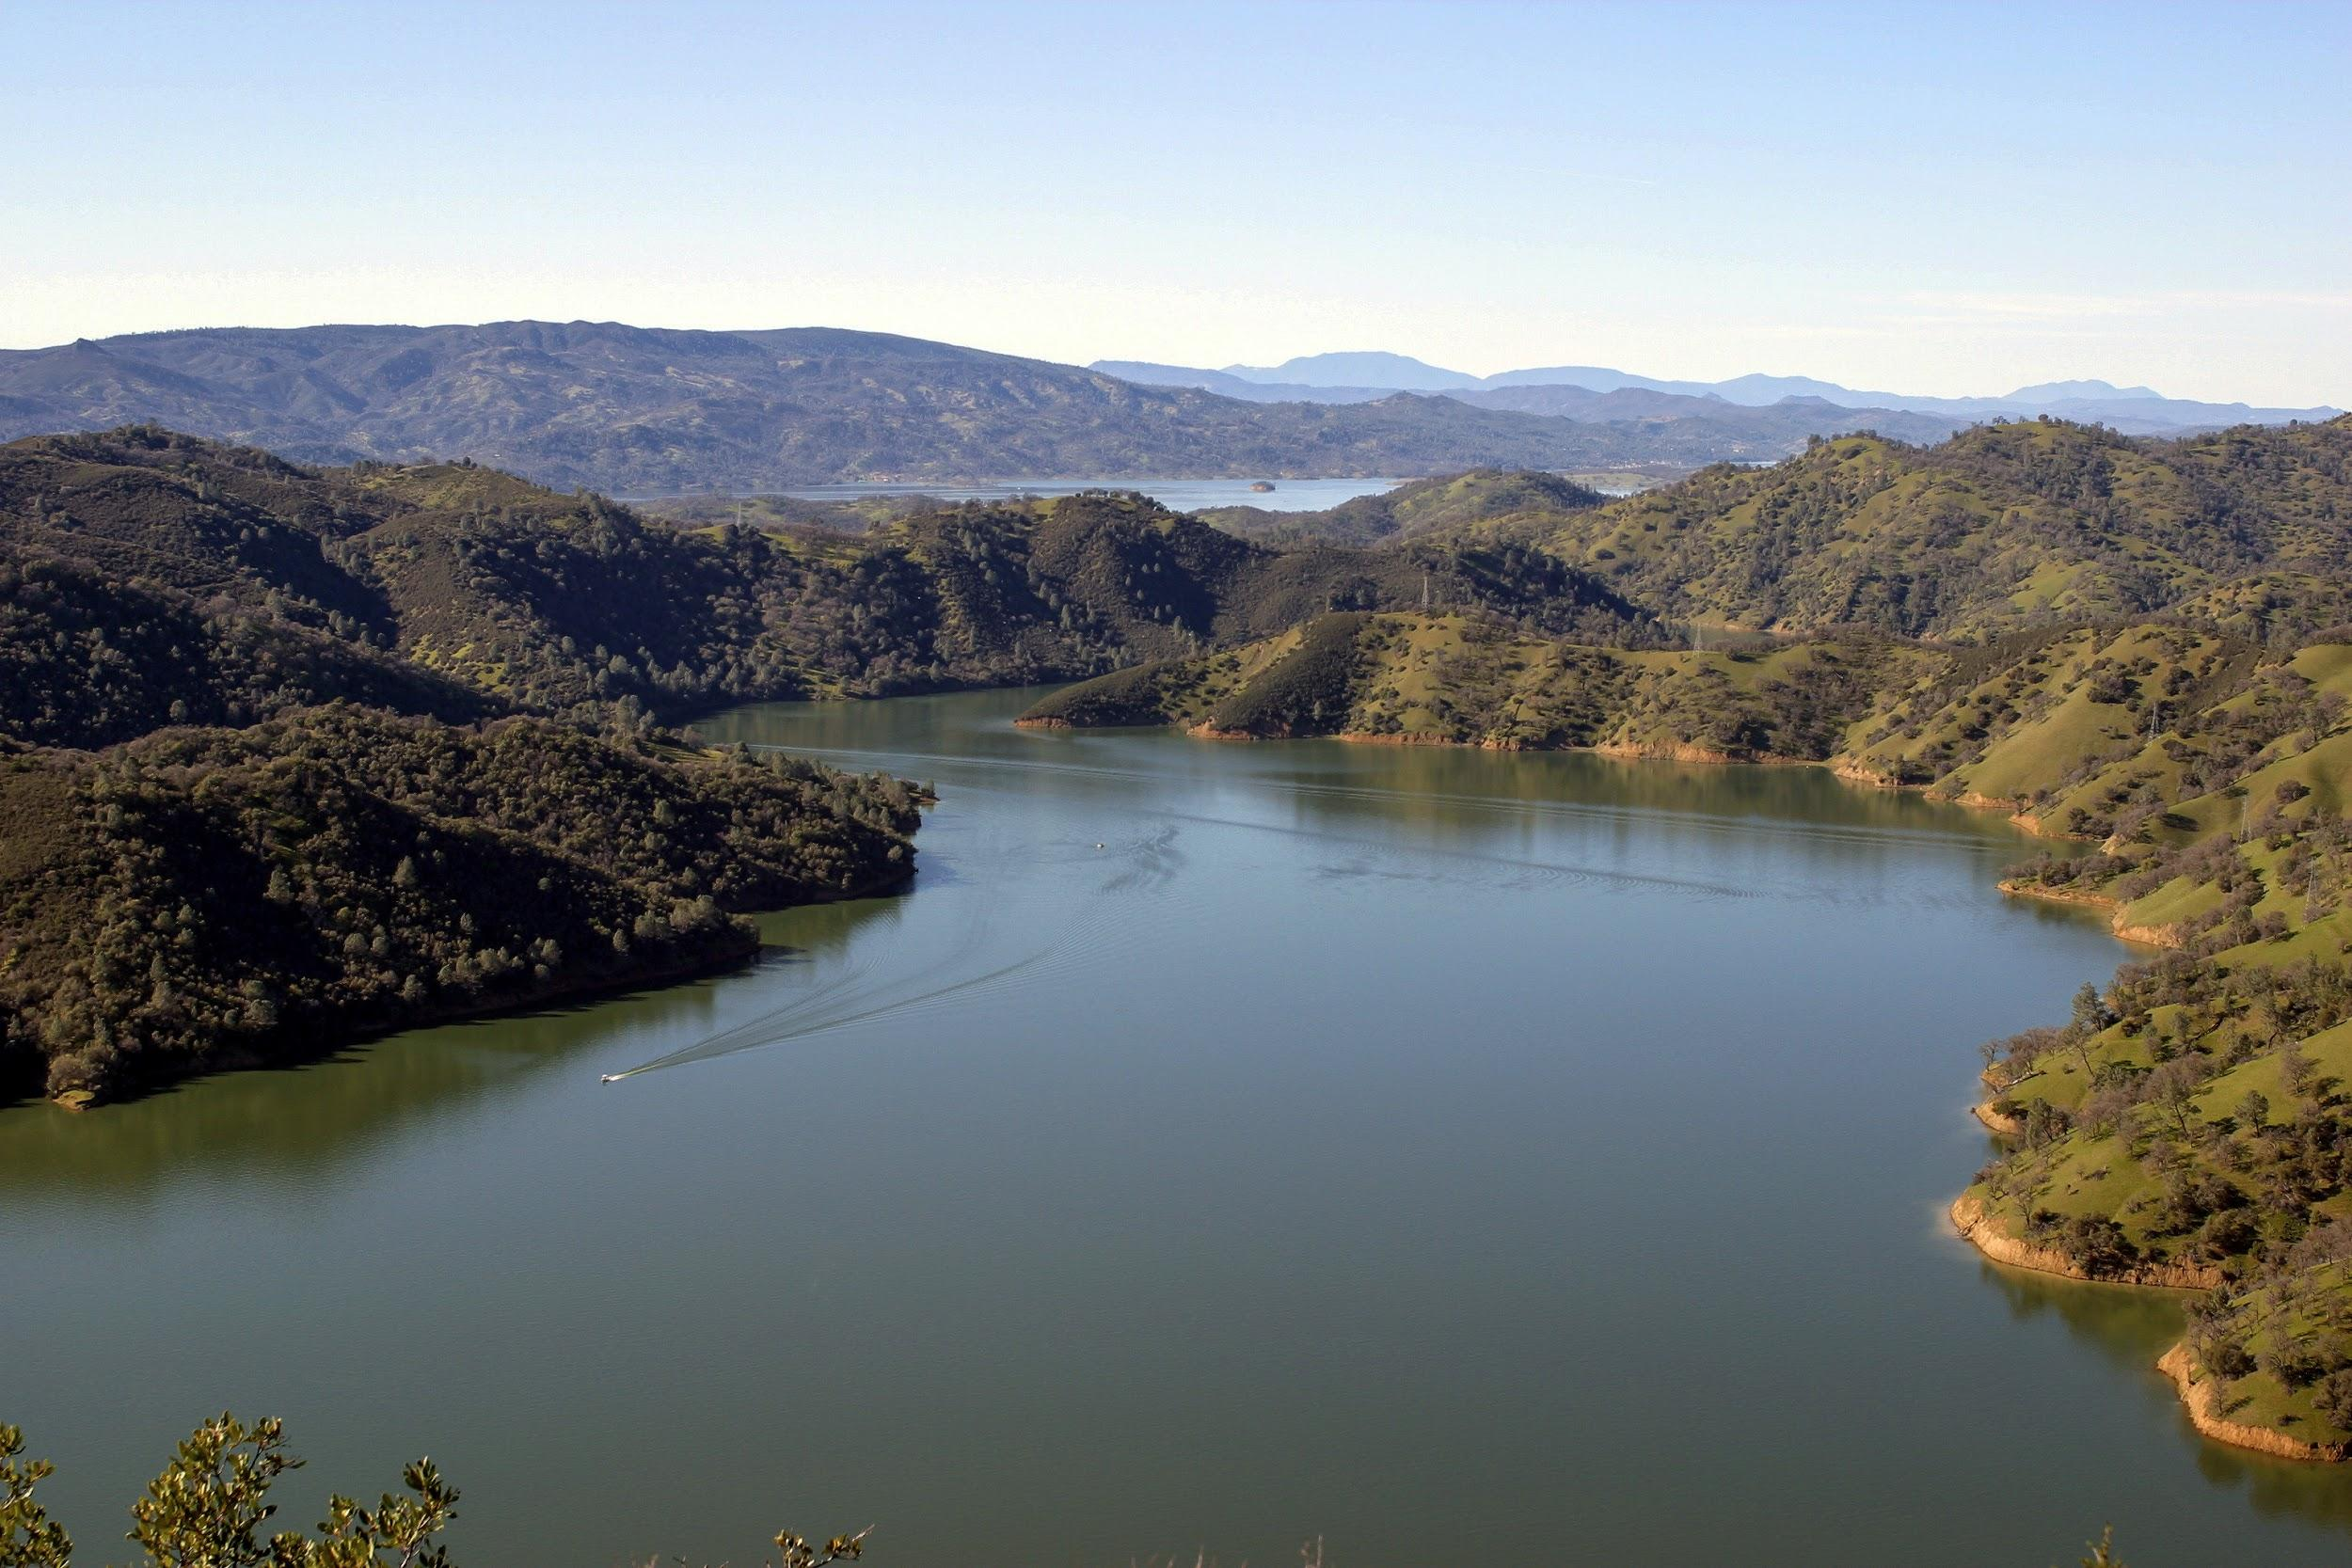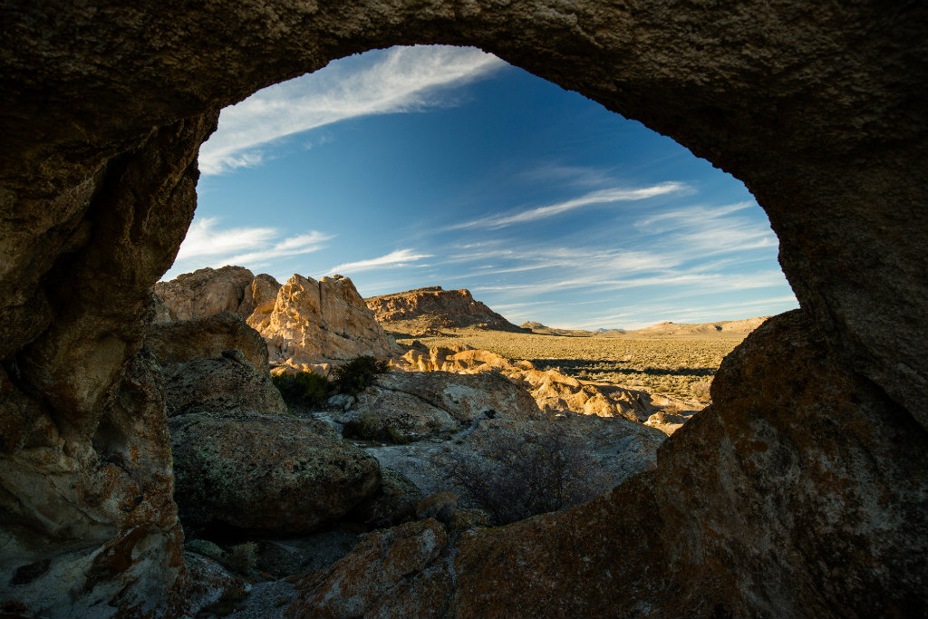

SMILE TWEET

INFORMATIONAL -- NO CALL TO ACTION

SIGN-ON PAGE -- CALL TO ACTION

ACTIVITY #5: PRODUCE FB POSTS [AFTER CLASS]

Produce three Facebook posts to accompany your social media campaign:
- Smile FB posts (use one of the images, no GIFS on FB)
- Informational FB post W/ No Call to Action
- FB post W/ Sign-On Page and Call to Action

SMILE FB POST

INFORMATIONAL -- NO CALL TO ACTION

SIGN-ON PAGE -- CALL TO ACTION

SUBMIT YOUR FINAL PRODUCT BY Tuesday, September 27 by 9:00am BY EMAILING YOUR WORKBOOK LINK TO FELLOWS@BARACKOBAMA.COM

