Assignment Feedback Guide - Social Media Strategy
Key Takeaways from the Webinar

Key Takeaways:

- Social Media is the most basic point of entry, as it reaches a wide audience for little money

- Your social media strategy engages audience with you message

- The social media strategic user flow helps you meet new users and bring them into your email list

CLASS REVIEW
Social Media Strategy

Social media is the most basic entry point to the digital ladder of engagement – as a user, it is easy to observe and be on the periphery of conversations. You’re meeting people where they are. Social media is largely used to amplify the organization’s message and move people up the ladder of engagement.

Strategic User Flow: Digital campaigns should always be planned with the idea of engaging their audience where they’re at and moving them up the digital ladder of engagement towards higher level asks. Your content and posts should be timed and work in tandem with each other so that your audience is continually engaged with a diverse array of different posts and asks to gain acquisitions and make further asks of them. The user flow is never accidental, and should always be thought through when planning a digital campaign.
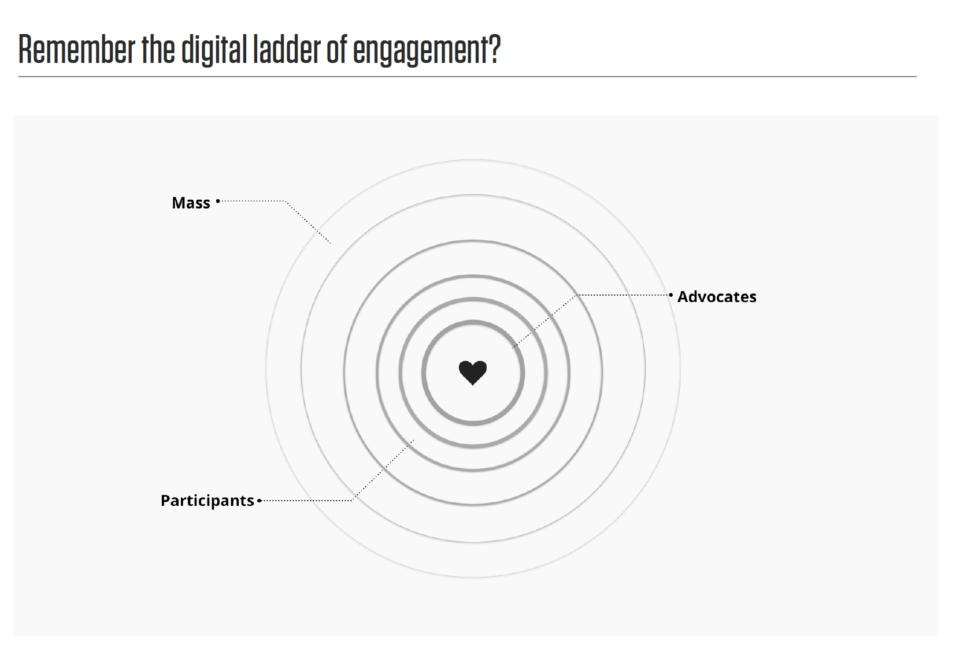

ASSIGNMENT
Due Tuesday, September 20, 2016 at 5:00pm CT

Follow @OFA on Twitter. If you do not have a Twitter account, you will need to create one for purposes of this fellowship. You’re going to follow a strategic user flow:

- Tweet 1: Once you have followed @OFA, scroll through their Twitter feed and select a tweet that stands out to you and screenshot it. This is your entry point to the strategic user flow.

- Tweet 2: After the next couple of hours (or days), keep an eye on @OFA – are there any new informational tweets that guide you to more information based on the topic you chose? Are you asked to do something? Screenshot this tweet

- Tweet 3: Now, once you see a tweet on the subject that asks you to take action, click on the call to action and take the action! Screenshot this tweet

- Follow the user flow until you get to the end! The end should be a donate page or a high bar ask (such as a call tool). You must document and screenshot every step of the user flow (emails, sign-on pages, autoresponders, and the donate page/call tool/etc…).

- Once you have completed the strategic user flow for your specific issue you found on @OFA, Click on the Workbook Here and fill out each step of the user flow, including screenshots!

Additionally, please read the article below and post your key takeaways to Connect.

Feedback Instructions

Below are some instructions for how fellows will receive feedback:

- At the bottom of their activity workbook, you will add a section that says, “OFA Staff – Assignment Feedback”

- Introduce yourself and your role at OFA. Your tone when giving feedback should be positive and encouraging while still being able to critique their work. For example, if a fellow has completely missed the point of the assignment, you might say something like, “It looks like you had some trouble with this assignment – I’d recommend going back to the training slides and recordings and reviewing it to make sure you understand the concepts. You should also feel free to reach out to Bobby at fellows@barackobama.com with any questions.”

- Look at their workbook and follow the user-flow they have chosen. Once you have done this, ask yourself these questions. Jot down some notes while you’re going through these questions:

  - Does the user-flow actually flow, or did they select random posts? Is the flow in order?

  - Do they demonstrate an understanding of moving up the ladder of engagement digitally, from being on the periphery of a conversation on social media to becoming an action taker?

  - Did their user flow include these social media assets:
    - Smile Tweet
    - Informational Tweet
    - Call to action tweet
    - Sign-on Page
    - Daisy Page – Donate/Volunteer Ask

  - If the user flow did not include the above assets, or was not complete, did the fellow acknowledge this and explain this in their answers to questions 1 and 2 after the user flow section?

  - Did the fellow take their time and make a good effort to understand the user flow from the perspective of an observer or an organization (bottom of the ladder of engagement)?

- Once you have completed answering these questions, you are ready to give your feedback. Write your feedback at the bottom section of the workbook. You can also use “comments” or “suggestion mode” in google docs if it is applicable.

