Campaign organizing bootcamp
Know your why; Personal Story

Goals for this training:
- Analyze underlying reasons why engaging in persuasive conversations is difficult, both individually and interpersonally
- Apply the theory of ‘knowing your why’ to people you will talk to in your organizing work
- Use the challenge, choice, outcome, ask framework to develop your personal story

Activity #1: Why is it difficult to persuade someone to change?

Listening to “This American Life,” and thinking of your own experiences, why is so difficult to change someone’s opinion?

Challenges to persuasion:

- Personal anxiety
- Interpersonal differences
- Fractured political context
- The ‘ask’ typically associated

Simon Sinek’s Framework:
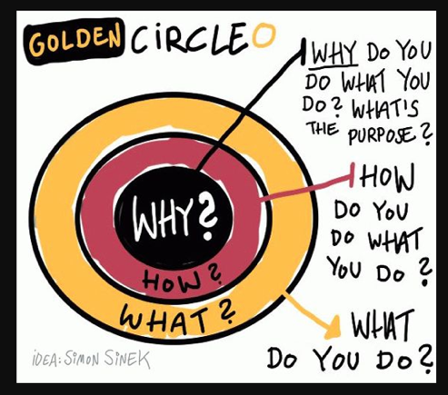
Critical incidents
“Events in your life that you recall being an important moment for you in clarifying what you believe.” -- Stephen Brookfield

Activity #2: A framework to knowing your why:

Step 1 - Your critical incident
- When was the first time you remember standing up for something you believe in?
- When was the first time you saw something unjust?
- When do you remember feeling pride in something you worked hard for?

NOTES:

Step 2 - Root values (List of values at the end of the worksheet for your reference)
- Looking at your critical incident, what are the root values that you believe in?

NOTES:

Step 3 - Why is this important to you?
- Practice sharing your critical incident, as well as the root values that underlie it.
- How can you share this in a way that resonates deeply for others?

Activity #4: Personal story framework

Challenge, choice, outcome, ask

Sample Personal Story:

Growing up in Central California, I have seen firsthand the importance of water in our community. As we speak right now, firefighters are risking their lives to contain deadly fires that are ravaging the Sierra Nevadas and surrounding communities, and I am truly terrified at the thought of my family - my parents, brothers, nieces, and nephews having to evacuate because the air they are breathing is toxic. Access to the quantity of water we need helps us contain these fires, as well as helps our local economy thrive with agriculture, jobs for farmers, and drinkable water from the ground table.”

In 2016, I voted for officials that would represent my beliefs about water access to government. I want our community’s future access to water to be guaranteed. If we continue on our current track, we know that the future of our community is shaky.”

Unfortunately, our pleas for creative solutions about the future of water in Fresno have gone unheard in Washington, which is why I am organizing with OFA and volunteers in our community to think of how we can address this critical problem.

Would you join me for a house meeting with other volunteers to brainstorm how we can make sure our member of Congress protects families from fearing about water safety in the future?

What changes will you make in conversations if you are trying to identify someone else’s why?

NOTES:

What changes will you make in conversations if you are trying to communicate your why?

NOTES:

RESOURCE #1: Values List (adapted from http://www.taproot.com/archives/37771):

